**Different types of Ensemble techniques:**

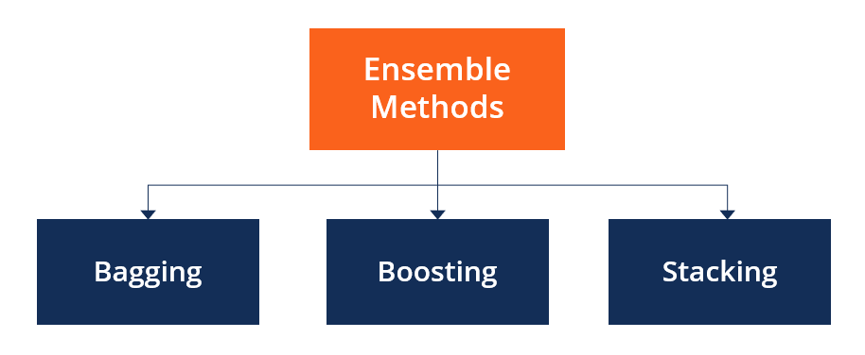

**Bagging:**

Bagging fits multiple models on different subsets of a training dataset, models are trained parallelly, then combines the predictions from all models.

Bagging Algorithm

1. **Random Forest**
2. **Bootstrapping:** creating a parallel model and passing the data in each model by dong row and feature sampling with replacement.

Bagging algorithms, such as

1. **Random Forest**

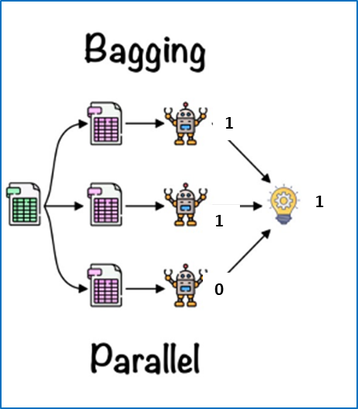

1. Aggregation: Aggregation refers to the process of **combining predictions** or **outputs** from multiple models to make a final prediction or decision. Aggregation can be done in various ways depending on the problem and the type of models used. For classification, we take the majority and in terms of regression we take the mean of the results obtained from different models.

**Boosting: -**

Boosting is a machine learning technique that combines multiple **weak** or **base** models to create a stronger and more accurate predictive model. It works by **sequentially** training the weak models in such a way that each subsequent model focuses on the instances that were incorrectly predicted by the previous models. The final prediction is made by **aggregating** the predictions of all the weak models, typically using a weighted voting or averaging scheme.

Boosting algorithms, such as

1. **AdaBoost**
2. **Gradient Boosting**
3. **XGBoost**

have been widely used and have achieved **state-of-the-art** results in various machine-learning tasks.

